Latin America Blending of Ethnic Groups Graphic Organizer

Native
European

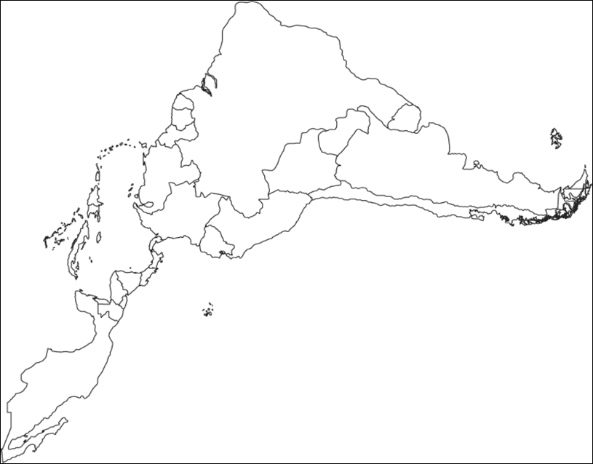

African

Terms for different types of peopleP
eninsules
Crillo
Mulatto
Mestizo

.

